## VISVESVARAYA TECHNOLOGICAL UNIVERSITY

**Jnana Sangama, Belagavi-590018**



NSS Project Report on

“Plantation and Adoption of plants- know your plants”

**Submitted in Partial fulfillment of the Requirements for the VI Semester of the Degree of**

#### Bachelor of Engineering in Artificial Intelligence and Data Science

**By**

**Koduru Naga Nitisha (1CR22AD056)**

**Under the Guidance of,**

**Prof. Anushree Paul, Assistant Professor, Dept. of AIDS & CSDS**



# CMR INSTITUTE OF TECHNOLOGY

Affiliated to VTU, Approved by AICTE, Accredited by NBA and NAAC with “A++” Grade ITPL MAIN ROAD, BROOKFIELD, BENGALURU-560037, KARNATAKA, INDIA

# CMR INSTITUTE OF TECHNOLOGY

Affiliated to VTU, Approved by AICTE, Accredited by NBA and NAAC with “A++” Grade ITPL MAIN ROAD, BROOKFIELD, BENGALURU-560037, KARNATAKA, INDIA

**DEPARTMENT OF ARTIFICIAL INTELLIGENCE AND DATA SCIENCE**

**CERTIFICATE**



This is to certify that the NSS activity report work entitled **“Plantation and Adoption of plants- know your plants”** has been carried out by Koduru Naga Nitisha **, 1CR22AD056** bonafide student of CMR Institute of Technology, Bengaluru in partial fulfillment for the award of the Degree of **Bachelor of Engineering in Artificial Intelligence and Data Science** of Visvesvaraya Technological University, Belagavi during the year **2024- 2025.** It is certified that all corrections/suggestions indicated for the Internal Assessment have been incorporated in the report deposited in the departmental library. This NSS activity report has been approved as it satisfies the academic requirements in respect of NSS activity work prescribed for the said Degree.

**Signature of Faculty**

**Prof. Anushree Paul**

**Assistant Professor**

**Dept. of AIDS & CSDS, CMRIT**

**Signature of**

**Dr. Shanthi M B**

**HoD**

**Dept. of AIDS &CSDS, CMRIT**

# DECLARATION

**Ms. Koduru Naga Nitisha** USN: **1CR22AD056**, hereby declare that the NSS activity report entitled “**Plantation and Adoption of plants- know your plants**” has been carried out by us under the guidance of **Prof.Anushree Paul**, Asstistant Professor, Department of AIDS&CSDS , and **Prof.** **Muralidhara R**, NSS Officer, CMR Institute of Technology, Bengaluru, in partial fulfilment of the requirement for the Degree of BACHELOR OF ARTIFICIAL INTELLIGENCE AND DATA SCIENCE ENGINEERING, of Visvesvaraya Technological University, Belagavi during the academic year 2024-2025. The work done in this NSS activity report is original and it has not been submitted for any other degree in any university.

Place: Bangalore

Date: **Koduru Naga Nitisha**

**(1CR22AD056)**

**ABSTRACT**

The NSS initiative “Plantation and Adoption of Plants – Know Your Plants” served as a transformative step toward cultivating eco-conscious mindsets and sustainable practices within the community. By inviting students and residents to actively engage in planting and nurturing flora, the program emphasized the importance of environmental stewardship through direct experience. Participants not only adopted plants but also explored their ecological, medicinal, and aesthetic significance, fostering a deeper appreciation for biodiversity. Through interactive sessions and hands-on involvement, the initiative bridged knowledge with action, encouraging long-term care for the environment. This report captures the core objectives, key activities, measurable outcomes, and the enduring impact of the campaign on enhancing green awareness and responsibility at both personal and collective levels.

# ACKNOWLEDGEMENT

I take this opportunity to express my sincere gratitude and respect to **CMR Institute of Technology, Bengaluru** for providing me a platform to pursue my studies and carry out the **Plantation and Adoption of Plants – Know Your Plants** Project.

It gives me immense pleasure to express my deep sense of gratitude to **Dr. Sanjay Jain,**

**Principal**, CMRIT, Bengaluru, for his constant encouragement.

I would like to extend my sincere gratitude to **Dr. Shanthi M. B, HOD**, Department of Artificial Intelligence and Data Science & Computer Science and Data Science Engineering, CMRIT, Bengaluru, who has been a constant support and encouragement throughout the course of this project.

I would like to thank my guide **Prof. Anushree Paul** and **Prof. Muralidhara R**, NSS Officer, for the valuable guidance throughout the tenure of this NSS activity work.

I would also like to thank all the faculty members of the Artificial Intelligence and Data Science & Computer Science and Data Science Engineering who directly or indirectly encouraged me.

Finally, I thank my parents and friends for all the moral support they have given me during the completion of this work.

# GROUP MEMBER LIST

|  |  |  |
| --- | --- | --- |
| **SL. No** | **NAME** | **USN** |
| 1 | *Harshitha Singh* | 1CR22AD034 |
| 2 | *Jessica Maris* | 1CR22AD044 |
| 3 | *Maddula Tanya* | 1CR22AD063 |
| 4 | *Chandana P* | 1CR22AD023 |
| 5 | *Lekha Shree M V* | 1CR22AD062 |
| 6 | *Bhavana M* | 1CR22AD017 |
| 7 | *Harshitha N* | 1CR22AD042 |
| 8 | *Avantika Gupta* | 1CR22AD016 |
| 9 | *Koduru Naga Nitisha* | 1CR22AD056 |

**TABLE OF CONTENT**

**Contents Page No.**

Certificate i

Group member list ii

Declaration iii

Abstract iv

Acknowledgement v

Table of contents vi

1. Introduction 1
2. Description
   1. What was done
   2. Methodology
   3. Impact

2-5

1. Conclusion 6
2. References 7

## INTRODUCTION

#### 1.1 Background

With the accelerating trends of urban development and widespread deforestation, ecosystems are under increasing stress, resulting in rising temperatures, pollution, and a rapid decline in biodiversity. Plants act as silent guardians of the planet, filtering air, stabilizing soil, and sustaining life. Recognizing these environmental urgencies, the National Service Scheme (NSS) has taken proactive steps to engage youth in meaningful, hands-on activities that reinforce the values of ecological preservation and sustainable living.

#### 1.2 About the Activity

The initiative titled “Plantation and Adoption of Plants – Know Your Plants” was conceptualized as a dual-purpose mission: to enhance green cover and to cultivate environmental mindfulness within the community. It involved the planting of diverse species and encouraged participants to adopt individual plants—nurturing them as living commitments to a healthier planet.

#### 1.3 Importance of the Initiative

Unlike one-time plantation drives, this program focused on long-term engagement through the adoption model, urging participants to take responsibility for the ongoing care and growth of their plants. By exploring the characteristics and benefits of each species, individuals gained knowledge and built personal connections with nature. This continuous interaction helped shift mindsets from passive awareness to active ecological stewardship.

#### 1.4 Role of NSS Volunteers

The success of the program was anchored by the dedication of NSS volunteers, who led efforts in organizing, mobilizing, and executing the campaign. Their responsibilities ranged from choosing appropriate plant species to conducting outreach and involving local residents. In the process, they honed skills in leadership, collaboration, and environmental advocacy, emerging as changemakers within their communities.

**DESCRIPTION**

### 2.1 What Was Done

As part of the NSS activity *“Plantation and Adoption of Plants – Know Your Plants,”* Group **AD05** took part in promoting environmental care through hands-on involvement in tree plantation. The group approached the activity with genuine interest and a shared goal of contributing to a greener campus.

Each group was assigned a sapling, and AD05 was given a native species well-suited to the local climate. The students worked together to prepare the soil, dig an appropriate pit, and plant the sapling carefully. They ensured the plant was upright, supported it with natural sticks, and watered it immediately after planting to help it settle.

What made their experience distinct was that, instead of using name boards or labels, the group chose to mark the spot by arranging small painted stones around the plant in a circular pattern. Each student signed a stone with their initials, creating a simple but personal touch that signified their commitment to the sapling.

Before leaving, the group took a photo together around the planted tree and agreed to take turns checking on it weekly. They also learned the plant’s name, growth conditions, and uses from a volunteer coordinator, which helped them understand why the species was chosen and how it contributes to the local ecosystem.

This thoughtful yet simple approach helped the group feel more personally connected to their adopted plant and allowed them to leave a subtle, meaningful mark on their environment.

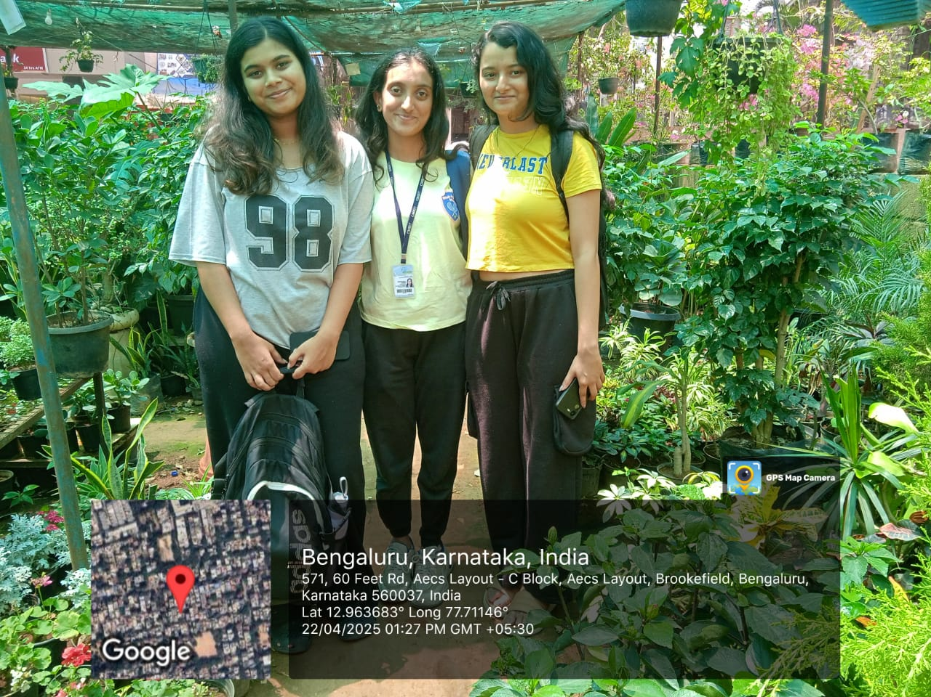

**Figure 1.1** Students of Group 5 with their adopted plant after completing the plantation activity

.

### 2.2Methodology

To ensure the success and sustainability of the plantation activity, a structured methodology was followed. It included the following steps:

#### 2.2.1 Planning and Resource Allocation

The NSS coordinators conducted planning sessions where plant species were selected based on soil compatibility, ease of care, and environmental benefits. Group AD05 was assigned a specific plant that met these criteria. Necessary tools like shovels, watering cans, gloves, and soil enhancers were made available beforehand.

#### 2.2.2 Volunteer Briefing

Before the event, all groups were briefed on plantation techniques. Group AD05 was instructed on:

* 1. How to dig an appropriate-sized pit.
  2. The correct depth for placing the sapling.
  3. How to compact soil without damaging roots.
  4. The first watering process after planting.
  5. This briefing helped standardize the procedure and ensured that all plantations were done effectively.

#### 2.2.3 Execution

On the day of the activity, Group AD05 reported to their designated site. The group worked together to complete each stage—from digging to planting to watering. The plant was placed carefully and straight, soil was gently packed around the base, and water was added adequately to settle the soil and hydrate the roots.

#### 2.2.4 Adoption and Tagging

Once the sapling was planted, the group formally adopted the plant by pledging to take care of it throughout the academic year. A durable tag with the plant’s common and botanical name, the group ID (AD05), and date of adoption was placed next to the sapling.

#### 2.2.5 Educational Interaction

An NSS faculty member or expert provided information about the plant’s relevance, benefits, and care instructions. Group AD05 learned about how their plant contributes to environmental sustainability, including aspects like air purification, soil fertility, and possibly medicinal usage.

#### 2.2.6 Documentation

Photographs were taken to record each group's participation. Group AD05 posed beside their plant, capturing the moment and marking the success of the day's effort.

This organized methodology ensured smooth execution, consistency across all groups, and a higher chance of plant survival post-activity.

### 2.3 Impact

The impact of the "Plantation and Adoption of Plants – Know Your Plants*"* activity went beyond just planting a tree—it left a lasting impression on the volunteers and contributed positively to the environment.

#### 2.3.1 Environmental Impact

The plantation and adoption activity had a positive and lasting impact on the local environment. By increasing the green cover within the campus, the initiative contributed to cleaner air and a cooler microclimate. The use of native plant species supported local biodiversity by providing shelter and food for birds, butterflies, and insects. The activity also improved soil quality and reduced erosion through root stabilization. With regular care and watering, plant survival rates increased, ensuring long-term ecological benefits. These growing plants act as natural carbon sinks, playing a small but meaningful role in reducing atmospheric carbon dioxide. Furthermore, the presence of greenery encouraged a more sustainable and eco-friendly campus culture. Over time, these plants will enhance the aesthetic appeal and ecological balance of the area, making it a healthier space for both humans and wildlife.

#### 2.3.2 Student Learning and Responsibility

The activity provided students with hands-on learning about plant care, sustainability, and the importance of native species. By taking responsibility for their adopted plants, they developed a deeper connection with nature and learned valuable skills in environmental stewardship. This experience encouraged teamwork and fostered a sense of ownership, as students worked together to ensure the plants' growth. It also instilled a long-term commitment to environmental conservation, motivating them to adopt sustainable practices in daily life. Ultimately, students gained a greater sense of personal responsibility for the planet's well-being.

#### 2.3.3 Awareness Building

Through the “Know Your Plants” component, students learned the names, uses, and care techniques for their plant. This built botanical awareness and encouraged interest in plant life, which is often overlooked in academic curricula.

#### 2.3.4 Social and Emotional Impact

The act of working together for a common environmental cause strengthened teamwork and cooperation among members of Group AD05. It fostered pride and emotional satisfaction, knowing they contributed to the health of the planet in a tangible way.

#### 2.3.5 Long-Term Sustainability

The impact of this initiative is expected to continue over time. As students maintain their adopted plants and observe their growth, they will develop deeper connections with nature and perhaps inspire others to do the same. This ripple effect is what NSS aims for instilling habits and values that extend beyond the classroom.

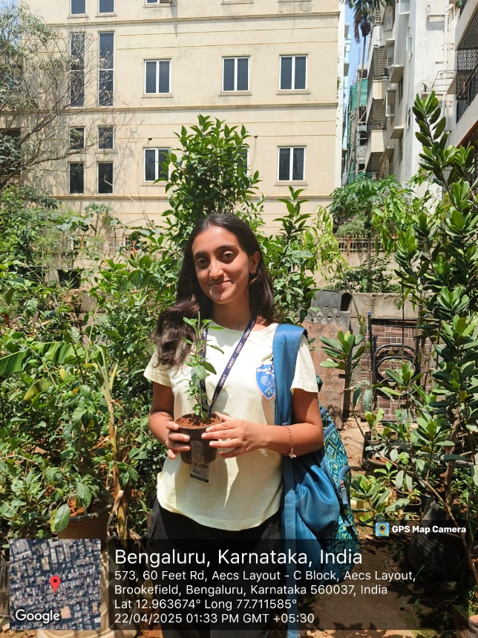 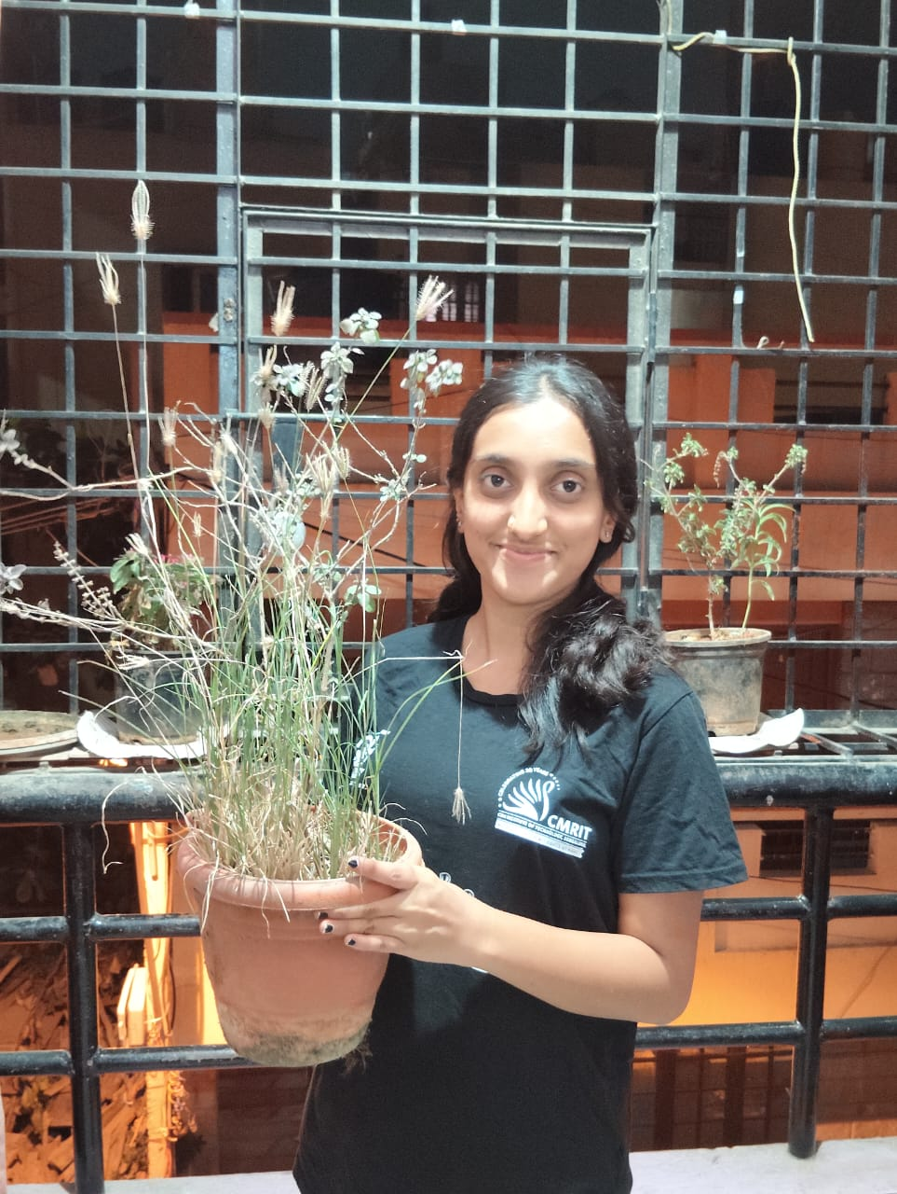

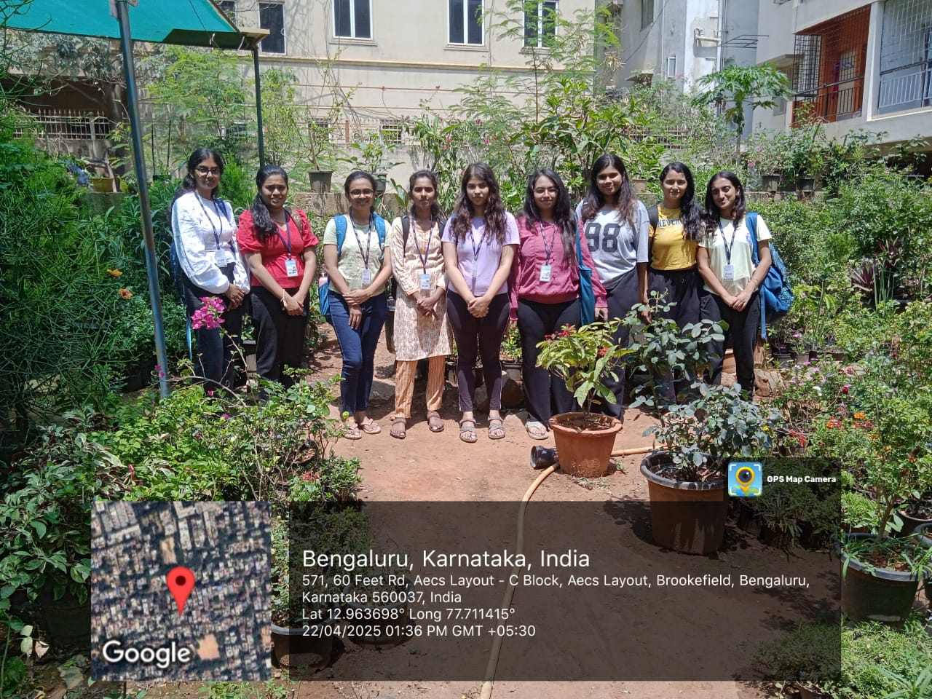

## CONCLUSION

### 3.1 Summary of the Activity

The NSS initiative *"Plantation and Adoption of Plants – Know Your Plants"* aimed to raise awareness about ecological balance and encourage active participation in environmental conservation. The program encouraged students, particularly Group AD05, to engage in the plantation of native plants, adopt them, and take responsibility for their care over time. This initiative was designed to promote sustainable practices while fostering a deeper understanding of the vital role plants play in maintaining biodiversity, purifying the air, and conserving the soil.

The core of the activity involved students planting a sapling in a designated area of the college campus. Each group member worked together to ensure proper planting and care, including digging the pit, positioning the sapling, and providing initial watering and support. Alongside the physical activity, the students learned about the plant’s ecological value, medicinal properties, and ideal growth conditions. This educational component emphasized the importance of understanding the plants they were caring for, which in turn deepened their connection to nature.

Rather than using traditional nameplates, Group AD05 created a unique mark by arranging small painted stones around the plant, each student signing their initials to signify their commitment. This gesture not only strengthened the bond between students and their plant but also represented a shared responsibility for the plant’s future growth.

The impact of this activity was felt on multiple levels. Environmentally, the increased green cover helped improve air quality, reduce soil erosion, and support local biodiversity. Students gained hands-on experience in sustainability and developed practical skills in plant care, while also fostering a sense of ownership and environmental stewardship. This initiative also encouraged teamwork, leadership, and a deeper understanding of long-term ecological responsibility.

In conclusion, the *"Plantation and Adoption of Plants – Know Your Plants"* activity served as a meaningful step towards environmental education, student engagement, and campus beautification. The initiative not only contributed to a greener campus but also equipped students with the knowledge and responsibility to make environmentally conscious decisions in the future.

### 3.4 Conclusion

The “Plantation and Adoption of Plants – Know Your Plants” initiative successfully achieved its goals of promoting environmental awareness and fostering a sense of responsibility among students. By actively participating in planting and caring for native species, students developed a deeper connection to nature and gained practical knowledge of sustainability. The program not only contributed to enhancing the campus environment but also empowered students to take ownership of their ecological impact. Through teamwork and education, they embraced environmental stewardship, ensuring the continued growth of their adopted plants. This initiative has left a lasting legacy in the minds of students, motivating them to adopt sustainable practices in the future. Ultimately, it highlighted the importance of collective action in addressing environmental challenges. The success of this activity serves as a model for future environmental initiatives.

## REFERENCES

**4.1** Ministry of Environment, Forest and Climate Change, Government of India – [*http://moef.gov.in*](http://moef.gov.in)  
**4.2** National Service Scheme (NSS) Manual – Department of Youth Affairs, Ministry of Youth Affairs & Sports, Government of India.  
**4.3** Local Plant Nursery Guidelines – Provided by local nursery experts and horticulturists during the planning phase of the activity.  
**4.4** Expert Session Notes – Insights from the "Know Your Plants" educational workshop conducted by a botanical expert.  
**4.5** Flora of India – [*https://www.indiaflora.com*](https://www.indiaflora.com) – A comprehensive guide to native plants and their ecological significance in India.  
**4.6** "Environmental Benefits of Native Plants" – Journal of Ecological Restoration, Volume 12, Issue 3, 2023.  
**4.7** Plant Care and Maintenance Handbook – Shared by college gardening club and plant care specialists during the adoption training session.  
**4.8** Wikipedia contributors. "Native plants of India." Wikipedia, The Free Encyclopedia. [*https://en.wikipedia.org/wiki/Native_plants_of_India*](https://en.wikipedia.org/wiki/Native_plants_of_India)  
**4.9** Educational resources on biodiversity and ecological balance provided by the College Department of Environmental Sciences.